14.(b).String reverse.

import java.util.Scanner;  
public class strrev {  
 public static void main(String[] args) {  
 String s;  
 int i,len=0;  
 System.*out*.println("enter a string : ");  
 Scanner a = new Scanner(System.*in*);  
 s=a.nextLine();  
 len=s.length();  
   
 for(i=len-1;i>=0;i--){  
 System.*out*.println(s.charAt(i));  
 }  
  
 }  
}

output.

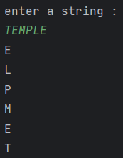

15.(a).Number palindrome

import java.util.Scanner;  
public class intpalindrome {  
 public static void main(String[] args) {  
 System.*out*.println("enter a number : ");  
 Scanner num = new Scanner(System.*in*);  
 int number = num.nextInt();  
 int n=number;  
  
 int rev=0,temp;  
 while(n!=0){  
 temp=n%10;  
 rev=rev\*10+temp;  
 n=n/10;  
 }  
 if(rev==number){  
 System.*out*.println("palindrome");  
 }  
 else{  
 System.*out*.println("not palindrome");  
 }  
 }  
}

output.

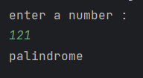

15.(b).String palindrome.

import java.util.Scanner;  
public class strpalindrome {  
 public static void main(String[] args) {  
 String s;  
 int i,len=0;  
 String rev="";  
 System.*out*.println("enter a string : ");  
 Scanner a = new Scanner(System.*in*);  
 s=a.nextLine();  
 char c[]=s.toCharArray();  
 len=s.length();  
  
 for(i=len-1;i>=0;i--){  
 rev=rev+c[i];  
 }  
 if(s.equals(rev)){  
 System.*out*.println("palindrome");  
 }  
 else{  
 System.*out*.println("not palindrome");  
 }  
  
 }  
}

output.

